
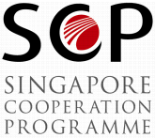
Search and Rescue Administrators

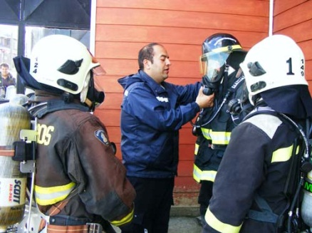
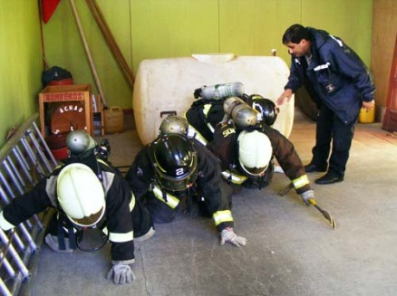
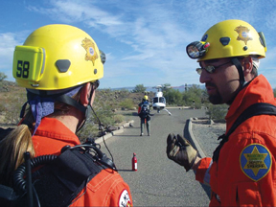

- MODALITY OF THE COURSE Presence

- DATE 24th August – 4th September

- LANGUAGE COURSE English

- COUNTRY Singapore

FECHA DE CIERRE EN EL IFARHU:
30 DE JUNIO DE 2015

- Course Objectives.
This course provides theoretical and practical knowledge on the planning and management of Search and Rescue (SAR) organizations. Participants involved in SAR operations will be equipped with knowledge and skills required to carry out their respective roles effectively and efficiently in an integrated emergency response system.

- Applicants ‘Profile.
Senior – level personnel such as Chiefs or Deputy Chiefs involved in the management and administration of a SAR organization or unit.

- Synopsis.
Topics include:
- Overview of a SAR System and its component
- Communications in SAR
- International provisions
- In-country cooperative arrangements
- SAR agreements and operating procedures
- Funding for SAR Units
- General trends and future developments in SAR
- Site visits and SAR Exercise (SAREX)

REQUIRED DOCUMENTS

Documents | Original | Copy
- A postulation letter must be delivered from the highest authority of the place of work directed to the IFARHU General Director Yesenia Rodriguez | 1 | -
- To fill out the IFARHU International Form. | 1 | -
- Tax clear (B/. 1.00) - Paz y Salvo. | 1 | -
- Program Special Form: http://www.scp.gov.sg/content/scpcourses_offered_aplicationprocedure/application_procedure.html | 1 | 1
- Pictures | 2
- College Diploma* | - | 2
- College Credits* | - | 2
- Curriculum Vitae. | - | 2
- ID card, both sides* | - | 2
- Passport* |  | 2
- Medical certificate | 1 | 1

OBSERVATIONS

- All the documents with* (Asterisk) need to be authenticate at IFARHU Ground Floor.
- The Regional Office on the exterior of Panama, have to present the entire necessary document 3 days before the closing date in the Office Panama-Central.

Contact the Department of International Scholarships

Yadira Quintero yquintero@ifarhu.gob.pa
Nelva de Domínguez nedominguez@ifarhu.gob.pa

Department of International Scholarships Flat N -6
Tel: 500-4719 ext. 2179

Building: UNICORP BUSINESS PLAZA Calle Ramón Arias, Urb. El Carmen

