AIRCRAFT ACCIDENT INVESTIGATION TECHNIQUES AND
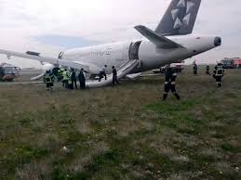
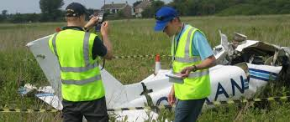

MANAGEMENT
- Country: Singapore
- Duration: March 21, to April 1 th, 2015
- Closing date for Aplication: January 29, 2016

- Course Objective.

This course provides an understanding of the complete aircraft accident investigation process, the knowledge and skills required to participate in and support formal investigations, and to conduct. Safety Management System (SMS) investigations in their own organizations.
- Synopsis and Methodology.
Topics include
- ICAO Annex 13
- Preparation and on the investigation
- Technical and operations investigation
- Accident site safety

- Management of accident investigations
- Understanding human factors in aircraft accidents
- Aviation medicine and pathology
- Organizational factors in safety from airlines perspective
- Approach and Landing Accident Reduction (ALAR) tool kit
- Writing the final report

- Applicants Profile

Personnel involved in accident investigations or aviation safety programmes from accident investigation agencies, civil aviation authorities airport authorities/operation air navigation service providers, airlines, military and air force, law enforcement agencies, and emergency response teams.

REQUIRED DOCUMENTS
Documents | Original | Copy
- A postulation letter must be delivered from the highest authority of the place of work directed to the IFARHU General Director Sonia de Luzcando. | 1 | -
- To fill out the IFARHU International Form. | 1 | -
- Tax clear (B/. 1.00) - Paz y Salvo. | 1 | -
- Program Special Form: http://www.scp.gov.sg/content/scp/courses_offered_applicationprocedure/application_procedure.html | 1 | 2
- Pictures | 2
- College Diploma* | - | 3
- College Credits* | - | 3
- Curriculum Vitae. | - | 3
- ID card, both sides* | - | 3
- Passport* |  | 3
- Medical certificate | 1 | 2

yquintero@ifarhu.gob.pa ; nedominguez@ifarhu.gob.pa;
Departamento de Becas Internacionales, Piso N° 6, Tel: 500-4719. Ext. 2179
Edificio: Unicorp Business Plaza;
Calle Ramón Arias, Urb. del Carmen-

