
CLIMATE CHANGE IMPACTS AND
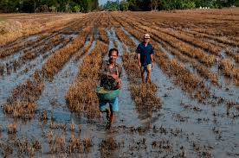
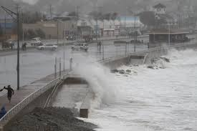
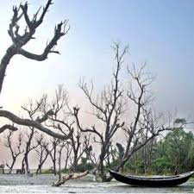
ADAPTATION STRATEGIES

- Country: Singapore
- Duration: 7 to 11 of September 2015
- Closing date for Aplication: July 10, 2015

- Objective.

This course shares Singapore’s experience in formulating measures to address the challenges and impacts of climate change Participants will gain a better understanding of the issues surrounding climate change, sustainability solutions and the importance of collective mitigating actions taken on a global scale.

- Synopsis and Methodology
Topics include
- Singapore’s policies and regulatory frameworks for climate change issues and developments.
- Regional predictions in climate change
- Economic evaluation, costs and benefits of mitigation and adaptation measures
- Climate change governance, effective regulations and enabling legislation
- United Nations Framework Convention on Climate Change (UNFCCC)
- Vulnerabilities and sustainable risk management

- Applicants Profile

Mid to senior level government officials (Directors/Deputy Directors/heads of Department with at least 2 years of working experience in policymaking for sustainability and environmental excellence or related fields..º

REQUIRED DOCUMENTS
Documents | Original | Copy
- A postulation letter must be delivered from the highest authority of the place of work directed to the IFARHU General Directora Yesenia Rodriguez. | 1 | -
- To fill out the IFARHU International Form. | 1 | -
- Tax clear (B/. 1.00) - Paz y Salvo. | 1 | -
- Program Special Form: http://www.scp.gov.sg/content/scp/courses_offered_applicationprocedure/application_procedure.html | 1 | 2
- Pictures | 2
- College Diploma* | - | 3
- College Credits* | - | 3
- Curriculum Vitae. | - | 3
- ID card, both sides* | - | 3
- Passport* |  | 3
- Medical certificate | 1 | 2

yquintero@ifarhu.gob.pa ; nedominguez@ifarhu.gob.pa;
Departamento de Becas Internacionales, Piso N° 6, Tel: 500-4719. Ext. 2179
Edificio: Unicorp Business Plaza;
Calle Ramón Arias, Urb. del Carmen

